KNOB HILL
4TH OF JULY PARADE
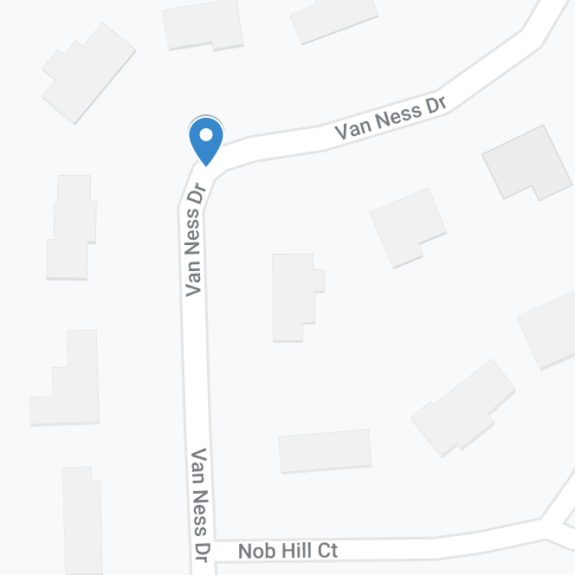
11:45 AM – Van Ness Dr. North of Nob Hill Ct.
Everyone gets snacks and drinks and kids get a chance to meet a firefighter!

If anyone would like to help with snack table setup and cleanup at Fairmont Ct., please contact Yolanda Richter at
(248) 417-3860 or email her at yolyor@yahoo.com
Have fun with your neighbors following one of Bloomfield Township’s firetrucks with your decorated bikes, trikes, scooters, strollers and more. There’s even a chance to win a prize!

